Question:
Fit a 2-degree polynomial $y=a_{0}+a_{1}x+a_{2}x^{2}$using normal equations / least squares in Python.
Aim:
Write a Python program to demonstrate to fit quadratic $y=a_{0}+a_{1}x+a_{2}x^{2}$using normal equations (no numpy).
Program:
from typing import List, Tuple

def build_sums(x_values: List[float], y_values: List[float]) -> dict:
n = len(x_values)
s = {
'n': n,
'sx': 0.0,
'sx2': 0.0,
'sx3': 0.0,
'sx4': 0.0,
'sy': 0.0,
'sxy': 0.0,
'sx2y': 0.0
}
for x, y in zip(x_values, y_values):
s['sx'] += x
s['sx2'] += x**2
s['sx3'] += x**3
s['sx4'] += x**4
s['sy'] += y
s['sxy'] += x * y
s['sx2y'] += (x**2) * y
return s

def print_table_and_sums(x_values: List[float], y_values: List[float]) -> None:
n = len(x_values)
s = build_sums(x_values, y_values)
print(f"{'x':>8}{'y':>10}{'x^2':>12}{'x^3':>12}{'x^4':>12}{'x*y':>12}{'x^2*y':>12}")
print("-" * 78)
for x, y in zip(x_values, y_values):
print(f"{x:8.4g}{y:10.4g}{x**2:12.4g}{x**3:12.4g}{x**4:12.4g}{(x*y):12.4g}{(x**2*y):12.4g}")
print("-" * 78)
print(f"n = {s['n']}, Σx = {s['sx']:.4g}, Σy = {s['sy']:.4g}, Σx^2 = {s['sx2']:.4g}, Σx^3 = {s['sx3']:.4g}, Σx^4 = {s['sx4']:.4g}")
print(f"Σxy = {s['sxy']:.4g}, Σx^2y = {s['sx2y']:.4g}\n")

def solve_3x3(A: List[List[float]], b: List[float]) -> List[float]:
"""Simple in-place Gaussian elimination to solve A x = b for 3x3 A."""
# Make copies
M = [row[:] for row in A]
rhs = b[:]
n = 3

# Forward elimination
for k in range(n):
pivot = M[k][k]
if abs(pivot) < 1e-14:
# try to swap with a lower row
for i in range(k+1, n):
if abs(M[i][k]) > 1e-14:
M[k], M[i] = M[i], M[k]
rhs[k], rhs[i] = rhs[i], rhs[k]
pivot = M[k][k]
break
if abs(pivot) < 1e-14:
raise ValueError("Singular matrix in solve_3x3")
# normalize row k
for j in range(k, n):
M[k][j] /= pivot
rhs[k] /= pivot
# eliminate
for i in range(k+1, n):
factor = M[i][k]
for j in range(k, n):
M[i][j] -= factor * M[k][j]
rhs[i] -= factor * rhs[k]

# Back substitution
x = [0.0]*n
for i in range(n-1, -1, -1):
val = rhs[i]
for j in range(i+1, n):
val -= M[i][j] * x[j]
x[i] = val / M[i][i] if abs(M[i][i])>1e-14 else val
return x

def fit_quadratic(x_values: List[float], y_values: List[float]) -> Tuple[float, float, float]:
if len(x_values) != len(y_values) or len(x_values) == 0:
raise ValueError("x_values and y_values must have same non-zero length.")
s = build_sums(x_values, y_values)
# Normal equations matrix and RHS for [a0, a1, a2]
A = [
[s['n'], s['sx'], s['sx2']],
[s['sx'], s['sx2'], s['sx3']],
[s['sx2'], s['sx3'], s['sx4']]
]
b = [s['sy'], s['sxy'], s['sx2y']]
a0, a1, a2 = solve_3x3(A, b)
return a0, a1, a2

def predict(a0: float, a1: float, a2: float, x: float) -> float:
return a0 + a1 * x + a2 * (x**2)

if __name__ == "__main__":
# Example points from notebook: (0,1), (1,6), (2,17)
x_values = [0.0, 1.0, 2.0]
y_values = [1.0, 6.0, 17.0]

# Print table & sums
print_table_and_sums(x_values, y_values)

# Fit quadratic
a0, a1, a2 = fit_quadratic(x_values, y_values)
print(f"Fitted quadratic: y = {a0:.6f} + {a1:.6f} x + {a2:.6f} x^2")

# Example predictions requested in the notebook
print(f"y(1.6) = {predict(a0, a1, a2, 1.6):.6f}")
print(f"y(3) = {predict(a0, a1, a2, 3.0):.6f}")
Result:
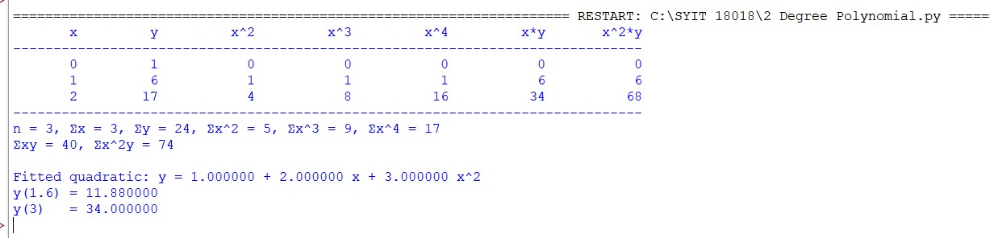

Conclusion:
The above Python program has been executed successfully.

